Chapter 13, Solution 34.

Using Fig. 13.103, design a problem to help other students to better understand how to find the input impedance of circuits with transformers.

Although there are many ways to solve this problem, this is an example based on the same kind of problem asked in the third edition.

Problem

Find the input impedance of the circuit in Fig. 13.102.

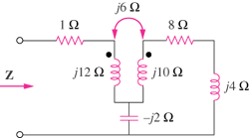

Figure 13.102

Solution

Insert a 1-V voltage source at the input as shown below.

j6
1 8


+
j12 j10 j4
1<0º V I₁ I₂
-

-j2

For loop 1,

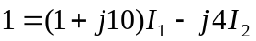 (1)

For loop 2,

(2)

Solving (1) and (2) leads to I₁=0.019 –j0.1068

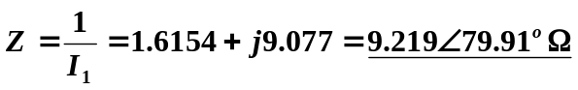

Alternatively, an easier way to obtain Z is to replace the transformer with its equivalent T circuit and use series/parallel impedance combinations. This leads to exactly the same result.

